**Name: Kaustav Ghosh**

**Section: C**

**Reg no:180905188**

**Roll no:29**

**Q7.4**

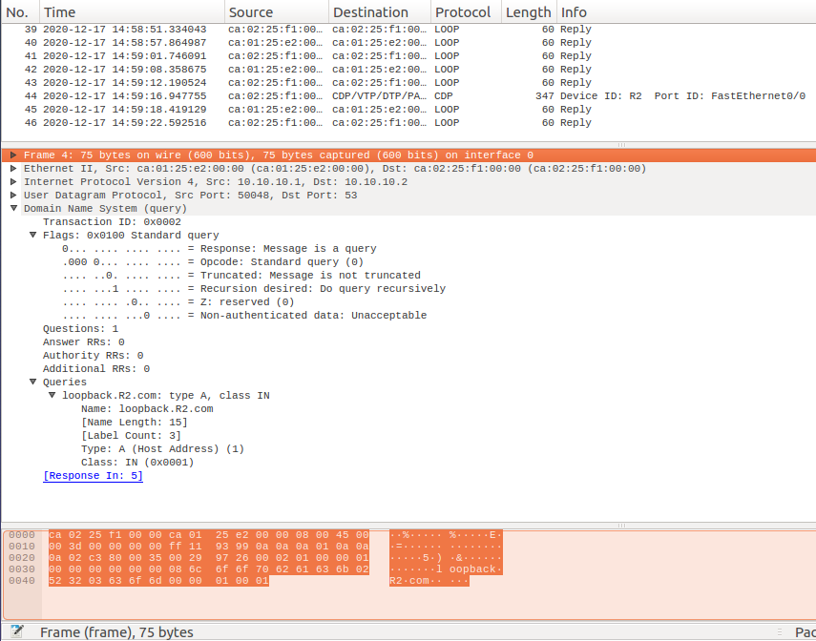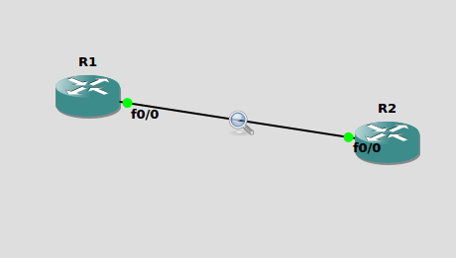

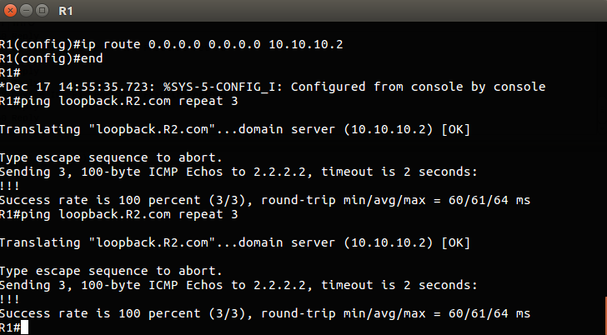

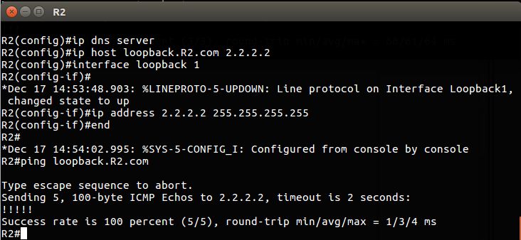

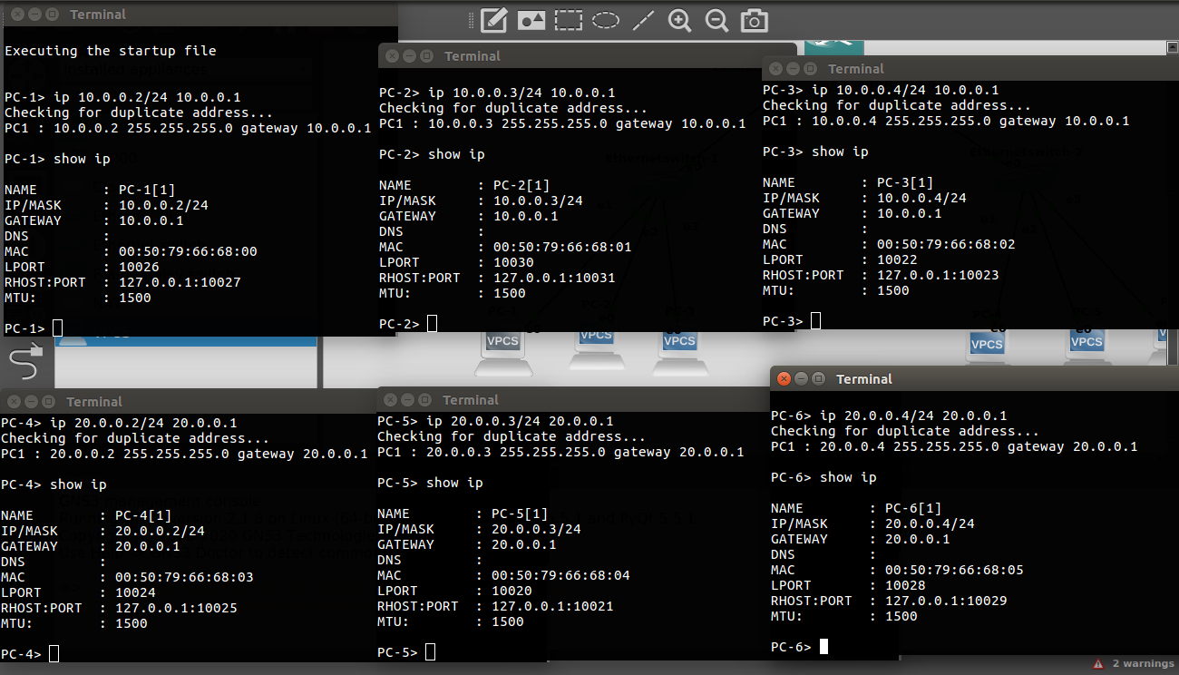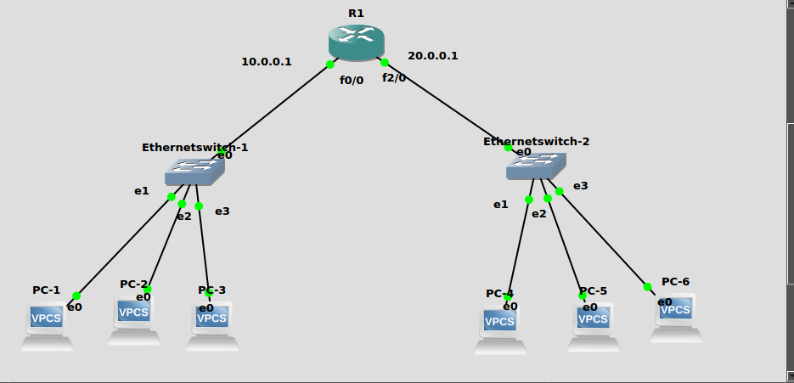**Q7.5**

**R1 IP and Hostname Configurations:**

***#enable***

***#config t***

***#hostname R2***

***#int f0/0***

***#ip address 10.0.0.0.1 255.255.255.0***

***#no shut***

***#do wr***

***#end***

***#int f0/0***

***#ip address 20.0.0.0.1 255.255.255.0***

***#no shut***

***#do wr***

***#end***

**Setting up R1 as DNS Server**

***#config t***

***#ip dns server***

***#ip host loopback.R1.com 2.2.2.2***

***#interface loopback 1***

***#ip address 2.2.2.2 255.255.255.255***

***#end***

***ip host PC1.com 10.0.0.2***

***ip host PC2.com 10.0.0.3***

***ip host PC3.com 10.0.0.4***

***ip host PC4.com 20.0.0.2***

***ip host PC5.com 20.0.0.3***

***ip host PC6.com 20.0.0.4***

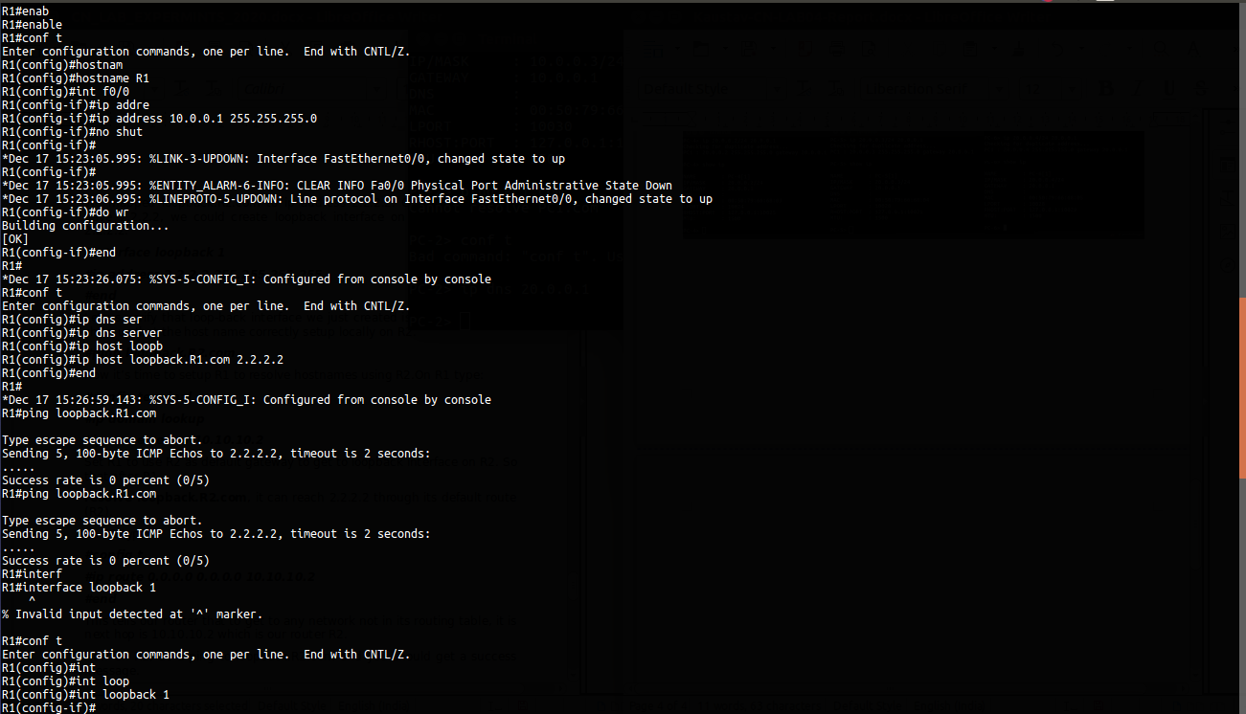

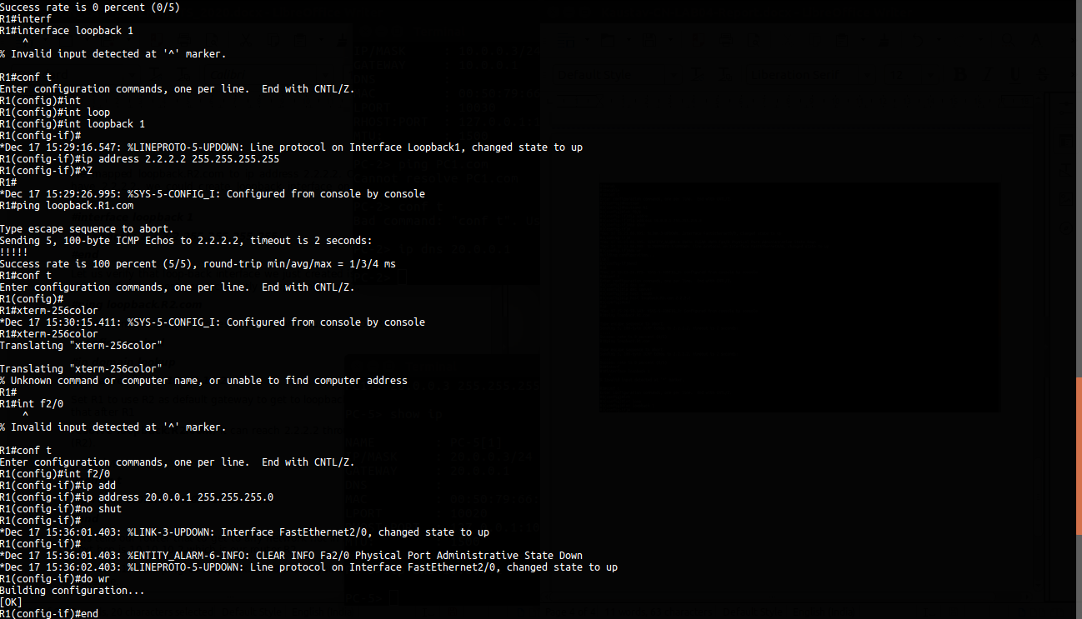

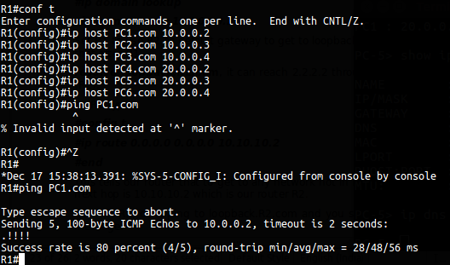

**PC1:**

**ip 10.0.0.2/24 10.0.0.1**

**ip dns 20.0.0.1**

**PC2:**

**ip 10.0.0.3/24 10.0.0.1**

**ip dns 20.0.0.1**

**PC3:**

**ip 10.0.0.4/24 10.0.0.1**

**ip dns 20.0.0.1**

**PC4:**

**ip 20.0.0.2/24 20.0.0.1**

**ip dns 10.0.0.1**

**PC5:**

**ip 20.0.0.3/24 20.0.0.1**

**ip dns 10.0.0.1**

**PC6:**

**ip 20.0.0.4/24 20.0.0.1**

**ip dns 10.0.0.1**

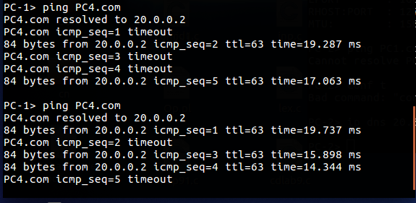**PC1 to PC4 PING Successful**

**PC5 to PC3 PING Succesful**

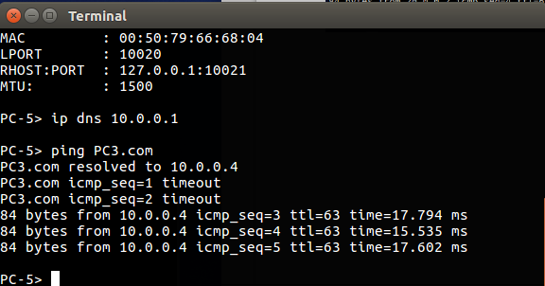

**Q8.1**

**Topology**

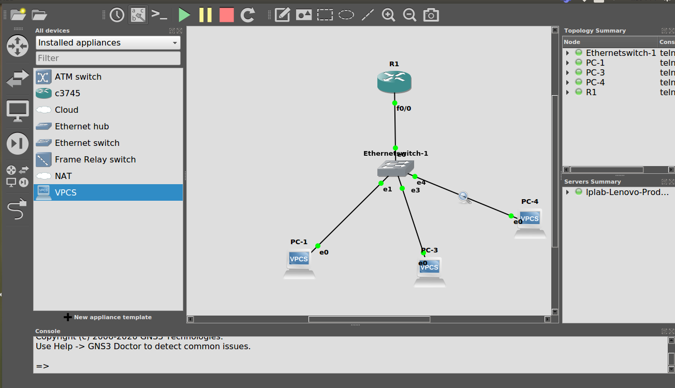

**Pinging pc1 to pc3**

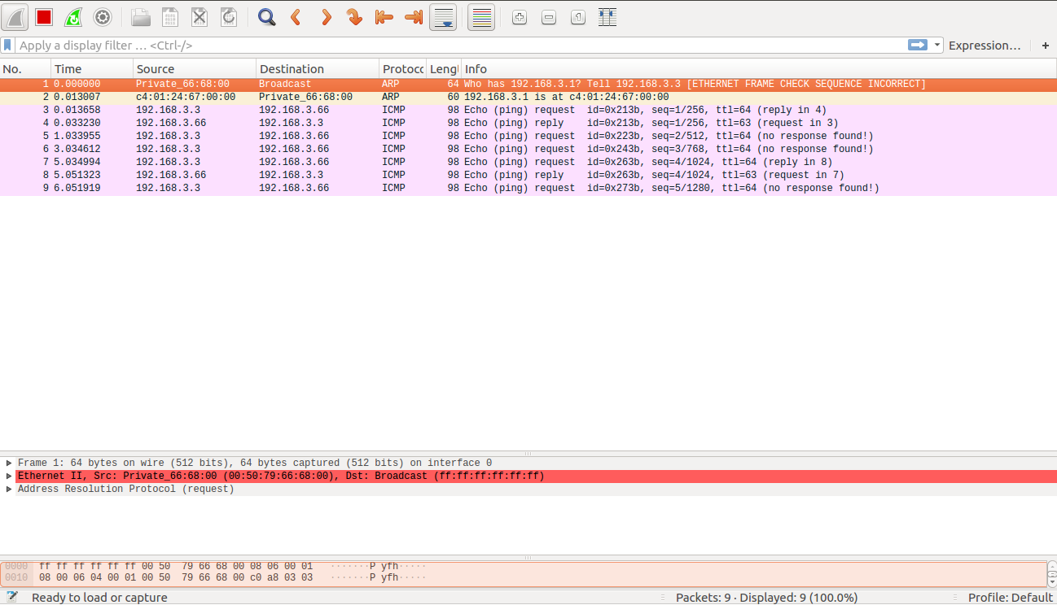

**Pinging pc3 to pc1**

